**Task 1**

server.py file

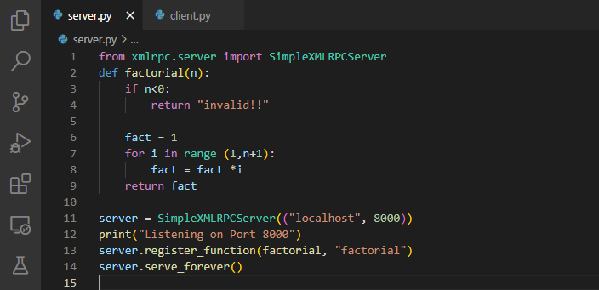

client.py file

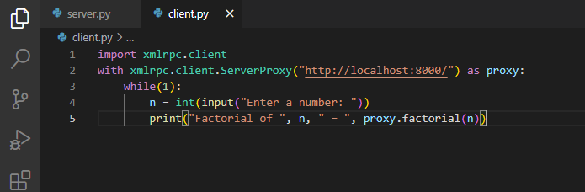

Outputs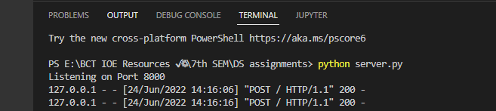

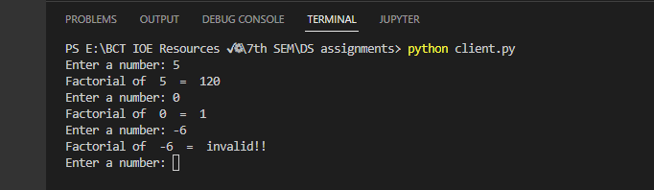

**Task 2**

FactorialInterface.java file

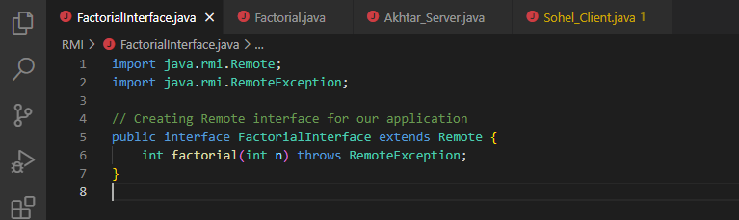

Factorial.java file

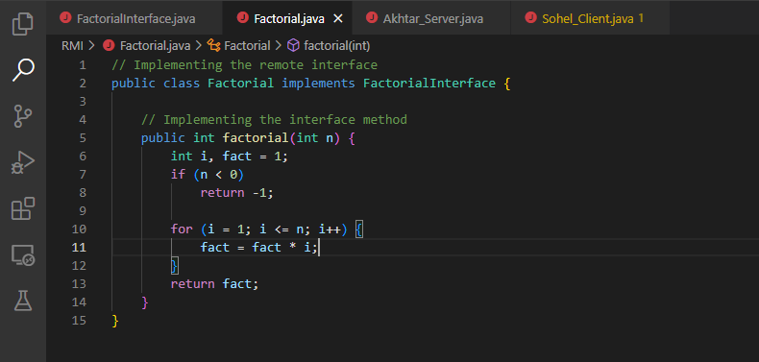

Akhtar_Server.java file

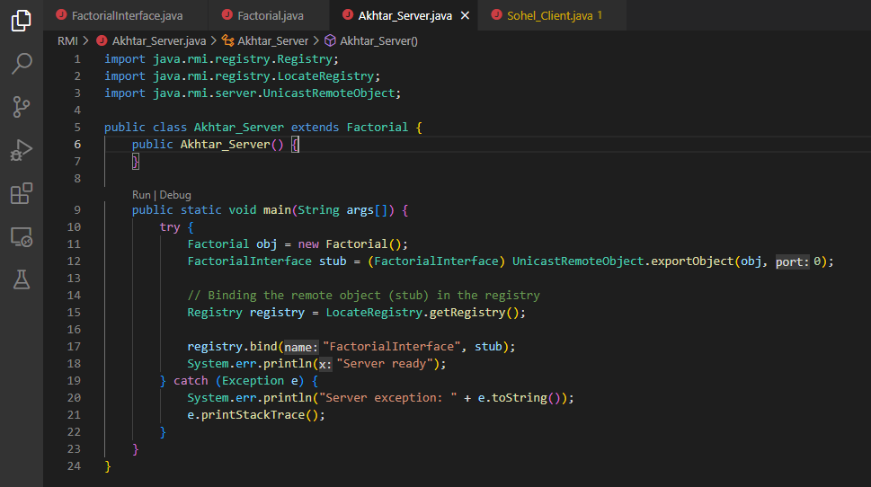

Sohel_Client.java file 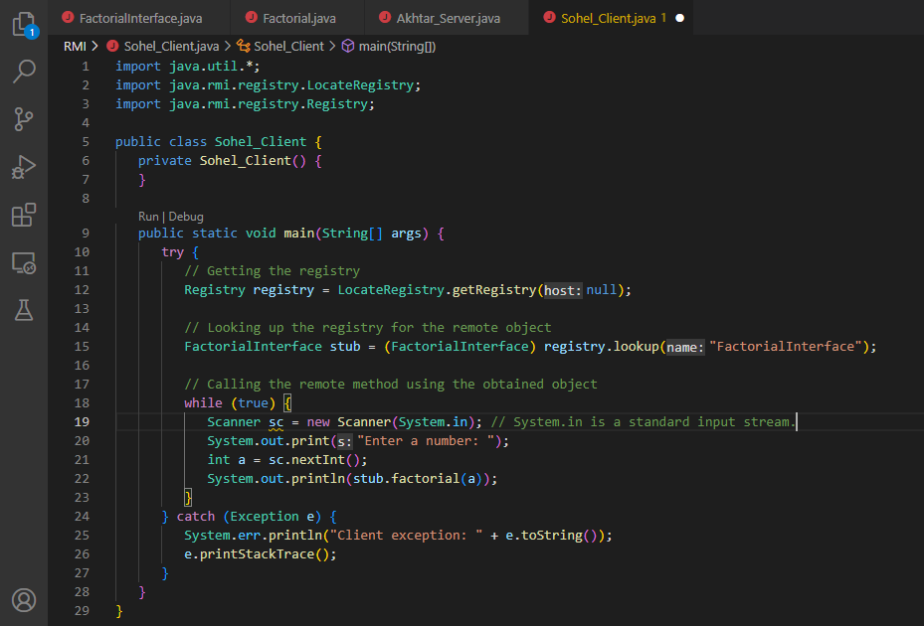

Outputs

